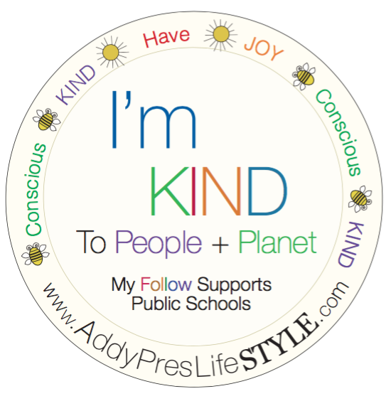

for PEOPLE. for PLANET. for THEM.

APYS 5 R’s for Families & Individuals

WHY MAKE THE EFFORT? Our TAKE-MAKE-TOSS lifestyles are rapidly reaching a tipping point, but there is still time to turn things around if we all commit to working together to create a new norm! The 5 R’s can make big impact if we know what they mean and how we can do our part, at home to participate in making these lifestyle changes. Reducing our waste is imperative to avoid unnecessary use of natural resources and help regenerate what has been lost. Waste is filling our landfills and damaging the environment. When food rots in these landfills, methane is released, harming the earth’s atmosphere. When food is wasted, it not only produces this harmful greenhouse gas but as it rots, it also wastes the resources that were used to produce, package, transport and store the food.

Zero Waste is the goal, but taking steps to get there in partnership with commerce and our waste management systems is the team effort for success. We’ve created a list to help your family do its part!

TIPS for your family to activate the 5 R’s (REFUSE, REDUCE, REUSE, RECYCLE, REGENERATE (ROT):

- REFUSE what you DO NOT NEED. If it’s not a necessity, do you really need it? Mindfully ask yourself this question each time you consider a purchase.

- REDUCE what you do NEED. Think REDUCE when you shop for food, toiletries, other goods & clothing. When purchasing food, plan your meals, make lists and buy local, organic & in bulk when available. Bring reusables to replace to-go items, straws, bags & water bottles. When purchasing clothing & other goods, buy higher quality goods that can stay in use longer. Look for opportunities to participate in commerce partner’s growing sustainable efforts. For example, Nike’s Adventure Club for kids, which brings new shoes to your doorstep regularly based on membership with the opportunity to send used items back to Nike to be upcycled into community playgrounds!

- REUSE what you consume. Use leftovers for another meal, freeze them or give them to your pets as a meal. Wash and reuse packaging, when you can. Repair damaged clothing & shoes instead of purchasing new. Look for ways to participate in commerce partner’s sustainable efforts. For example, Patagonia’s Worn Wear line, which collects, repairs & shares used gear to keep it in use longer.

- RECYCLE what you cannot REFUSE, REDUCE or REUSE. Recycling is not a sole solution. In fact, we now know that only 9% of all the plastic ever produced has been recycled. Far more waste assumed to be recycled ends up in landfills, where it pollutes and destroys the environment. Learn more about your local waste management system to see what items truly are recycled. Be sure to rinse recyclables before putting them to waste. Please visit the APYS Plastic Pollution Activation page to learn more about waste sorting for recycling.

- REGENERATE/ROT what is left should have the ability to be returned to nature for the earth to do its work. If you have space in your yard, you can create this family project! We recommend the following top tips:

  - Make sure you mix food waste with carbon rich material to balance out the nitrogen rich food waste.
  - For every bucket of food waste you add to the compost pile, you should add 2-3 buckets of dried leaves, shredded newspaper and cardboard.
  - Keep the pile covered with your carbon material and keep food from being exposed. This reduces flies, rodents & smells.
  - You want your pile to remain moist to the consistency of a wrung out kitchen sponge. Water your pile, if needed, or keep it covered from too much water.
  - Make sure the pile has air. Air is needed for aerobic bacteria to do their work. Without air, anaerobic will take over and cause odors. To get air into your pile, make sure you build the pile with air flow, or turn the pile. Chicken wire offers a great barreling opportunity.
  - Make your compost pile a community effort, be resourceful and turn other’s waste into life filled compost for your garden! Please learn more by visiting Rob Greenfield’s full guide to composting at: www.robgreenfield.org/composting

